 | 12.1.47 Editors - Geometry Nodes Editor - Header - Add Menu - Utilities - Math
Table of content
Detailed table of content 1
Add menu - Utilities - Math 6
Bit Math 6
Boolean Math 7
Integer Math 8
Clamp 8
Compare 9
Float Curve 10
Float to Integer 12
Hash Value 12
Map Range 13
Math 14
Mix 19

Detailed table of content
Detailed table of content
Detailed table of content 1
Add menu - Utilities - Math 6
Bit Math 6
Inputs 6
Properties 6
Operation 6
And 6
Or 6
Exclusive Or 6
Not 6
Shift 6
Rotate 6
Output 7
Boolean 7
Boolean Math 7
Inputs 7
Boolean 7
Properties 7
Operation 7
And 7
Or 7
Not 7
Not And (NAND) 7
Nor (NOR) 7
Equal (XNOR) 7
Not Equal (XOR) 7
Imply (IMPLY) 7
Subtract (NIMPLY) 7
Output 8
Boolean 8
Integer Math 8
Inputs 8
Value 8
Properties 8
Functions 8
Output 8
Value 8
Clamp 8
Inputs 8
Value 8
Min 8
Max 9
Properties 9
Clamp Type 9
Min Max 9
Range 9
Outputs 9
Result 9
Compare 9
Inputs 9
A, B 9
Properties 9
Input Type 9
Operation 9
A is less than B 9
A is lesser than or equal B 10
A is greater than B 10
A is greater than or equal B 10
A is equal B 10
A is not equal B 10
Output 10
Result 10
Float Curve 10
Inputs 10
Factor 10
Attribute 10
Properties 10
Curve Field 10
Channel buttons 10
Navigation elements 11
Zoom in and out 11
Use Clipping 11
Tools 11
Reset View 11
Extend horizontal 11
Extend extrapolated 11
Reset Curve 11
Curve edit field 11
Selecting Points 11
Adding Points 11
Curve point settings 12
Vector Handle 12
Auto Handle 12
Auto Clamped Handle 12
Output 12
Value 12
Float to Integer 12
Inputs 12
Float 12
Properties 12
Rounding Mode 12
Outputs 12
Integer 12
Hash Value 12
Input 13
Value 13
Seed 13
Properties 13
Data Type 13
Output 13
Hash 13
Map Range 13
Inputs 13
Value 13
From Min 13
From Max 13
To Min 14
To Max 14
Properties 14
Data Type 14
Interpolation Type 14
Clamp 14
Outputs 14
Value 14
Math 14
Inputs 14
Value 14
Addend 14
Base 14
Exponent 14
Epsilon 15
Distance 15
Min 15
Max 15
Increment 15
Scale 15
Degrees 15
Radians 15
Properties 15
Operation 15
Functions 15
Add 15
Subtract 15
Multiply 15
Divide 15
Multiply Add 16
Power 16
Logarithm 16
Square Root 16
Inverse Square Root 16
Absolute 16
Exponent 16
Comparison 16
Minimum 16
Maximum 16
Less Than 16
Greater Than 16
Sign 16
Compare 16
Smooth Minimum 16
Smooth Maximum 16
Rounding 17
Round 17
Floor 17
Ceil 17
Truncate 17
Fraction 17
Modulo 17
Wrap 17
Snap 17
Ping-pong 17
Trigonometric 17
Sine 17
Cosine 17
Tangent 17
Arcsine 17
Arccosine 17
Arctangent 17
Arctan2 18
Hyperbolic Sine 18
Hyperbolic Cosine 18
Hyperbolic Tangent 18
Conversion 18
To Radians 18
To Degrees 18
Clamp 18
Outputs 18
Value 18
Use Clipping 18
Delete Points 18
Curve window 18
X / Y values 18
Mix 19
Input 19
Float 19
Factor 19
A 19
B 19
Properties 19
Clamp Factor 19
Output 19
Result 19

Add menu - Utilities - Math
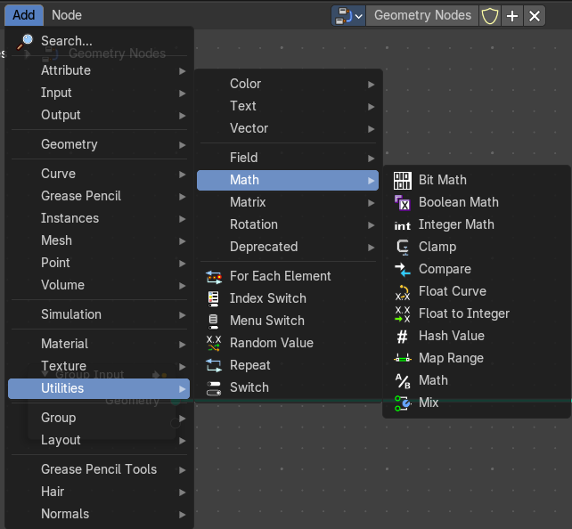
Utility nodes are mainly for mathematical operations.

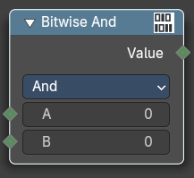
Bit Math
Performs a bit math operation between its inputs.

Inputs
The inputs depends of the chosen method.

Properties

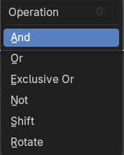
Operation

And
Returns a value where the bits of A and B are both set.

Or
Returns a value where the bits of either A or B are set.

Exclusive Or
Returns a value where only one bit of A and B is set.

Not
Returns the opposite bit value of A, in decimal it is equivalent of A = -A -1

Shift
Shifts the bit values of A by the specified Shift amount. Positive values shift left, negative values shift right.

Rotate
Rotates the bit values of A by the specified Shift amount. Positive values rotates left, negative values rotates right.

Output

Boolean
Standard Boolean output.

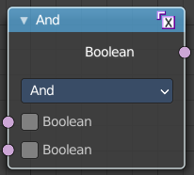
Boolean Math
The Boolean Math node performs a basic logical operation between its inputs.

Inputs

Boolean
Two standard Boolean inputs.

Properties

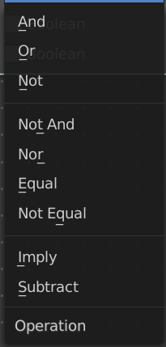
Operation

And
True if both inputs are true.

Or
True if either or both inputs are true.

Not
True if both inputs are false.

Not And (NAND)
True when at least one input is false.

Nor (NOR)
True when both inputs are false.

Equal (XNOR)
True when both inputs are equal.

Not Equal (XOR)
True when both inputs are different.

Imply (IMPLY)
True unless the first input is true and the second is false.

Subtract (NIMPLY)
True when the first input is true and the second is false.

Output

Boolean
Standard Boolean output.

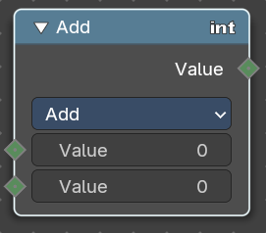
Integer Math
The Boolean Math node provides mathematical operations with integers.

Inputs

Value
Two standard value inputs.

Properties

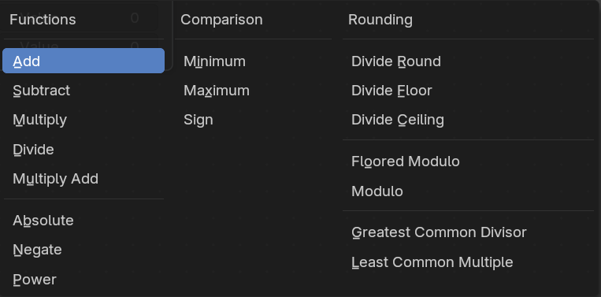
Functions
The available mathematical functions to manipulate the input integers.

Output

Value
The value output.

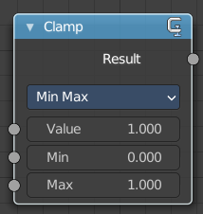
Clamp
Clamps a value between a minimum and a maximum.

Inputs

Value
The input value to be clamped.

Min
The minimum value.

Max
The maximum value.

Properties

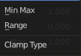
Clamp Type

Min Max
Clamp values using Min and Max values.

Range
Clamp values between Min and Max range.

Outputs

Result
The input value after clamping.

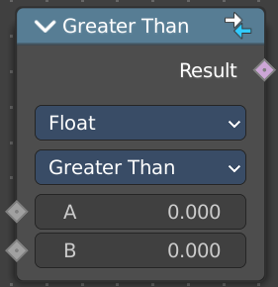
Compare
The Compare node takes two inputs and does a math comparison between them.

Inputs

A, B
Standard float value input.

Properties

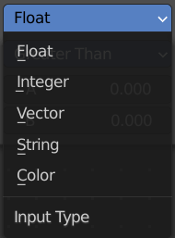
Input Type
What kind of data to compare.

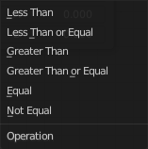
Operation

A is less than B
True if A is smaller than B.

A is lesser than or equal B
True if A is smaller or equal than B.

A is greater than B
True if A is bigger than B.

A is greater than or equal B
True if A is bigger or equal than B.

A is equal B
True if A and B are the same.

A is not equal B
True if A and B are different.

Output

Result
Standard Boolean output.

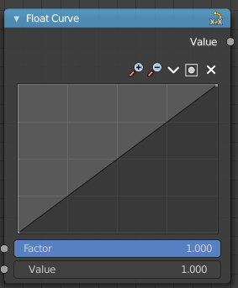
Float Curve
The Float Curve node maps an input float to a curve and outputs a float value. This curve can then be used for profiles for example.

Inputs

Factor
How strong the input influences the output value.

Attribute
The input value.

Properties

Curve Field

Channel buttons
Clicking on one of the channels displays the curve for each.
C (Combined RGB), R (Red), G (Green), B (Blue).

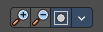
Navigation elements
They are described from left to right.

Zoom in and out
The two buttons with the magnifying glass at it zooms in and out in the curve window.


Use Clipping
Clipping options. Set up clipping for the stroke.

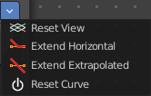
Tools
Tools is a menu where you can find some curve related tools.

Reset View
Resets the curve windows zoom.

Extend horizontal
Extends the curve before the first curve point and behind the last curve point horizontally.

Extend extrapolated
Extends the curve before the first curve point and behind the last curve point extrapolated.

Reset Curve
Resets the curve to the initial shape.

Curve edit field
Create and tweak a Bezier curve that varies the input levels (X axis) to produce an output level (Y axis).

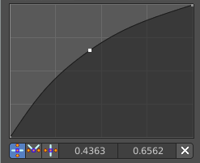
Selecting Points
You can select curve points. This reveals two edit boxes for the x and y coordinate of this point.
Selected points can be moved around. Left click at them, hold the mouse button down and move them to a new location.

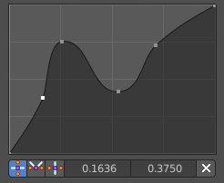
Adding Points
You can add new curve points by simply left clicking at the curve. Move the mouse to position them where you need it.

Curve point settings
When you have a point selected then you will reveal further settings at the bottom.

Vector Handle
Set handle type to Vector.

Auto Handle
Set handle type to Auto.

Auto Clamped Handle
Set handle type to Auto Clamped.

Output

Value
The output value.

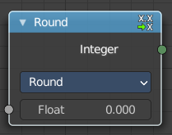
Float to Integer
Converts a floating point value into an integer value.

Inputs

Float
The input float value.

Properties

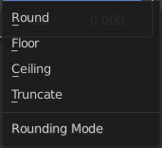
Rounding Mode
How the float value should be converted.

Outputs

Integer
The output integer value.

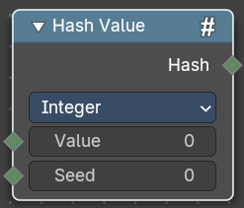
Hash Value
The hash value converts a value input into a hashed value.
Note that Hashes cannot be relied upon to be used as unique identifiers because they are not guaranteed to be unique. It can be used to generate somewhat stable randomness especially in cases where White Noise does not offer enough flexibility.

Input

Value
The input value.

Seed
A seed to randomize the value.

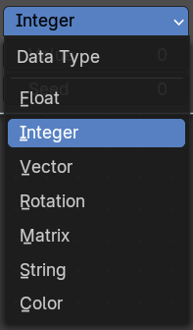
Properties

Data Type
What data type to create.

Output

Hash
The hash value output.

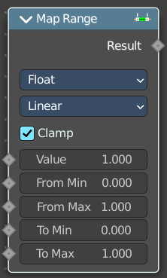
Map Range
This node converts (maps) an input value range into a destination range. By default, values outside the specified input range will be proportionally mapped as well. This node is similar to Map Value node but provides a more intuitive way to specify the desired output range.

Inputs

Value
Standard value input.

From Min
Start of the input value range.

From Max
End of the input value range.

To Min
Startof the destination range.

To Max
End of the destination range.

Properties

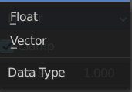
Data Type
The data type to calculate.

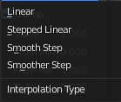
Interpolation Type
how to interpolate the values between min and max.

Clamp
Clamps values to Min/Max of the destination range.

Outputs

Value
Standard value output.

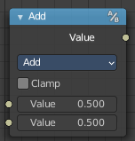
Math
The Math Node performs math operations.

Inputs
The inputs of the node are dynamic. Some inputs are only available with certain operations. For example, the Addend input is only available in the Multiply Add operator.

Value
Input Value. Trigonometric functions read this value as radians.

Addend
Input Addend.

Base
Input Base.

Exponent
Input Exponent.

Epsilon
Input Epsilon.

Distance
Input Distance.

Min
Input Minimum.

Max
Input Maximum.

Increment
Input Increment.

Scale
Input Scale.

Degrees
Input Degrees.

Radians
Input Radians.

Properties

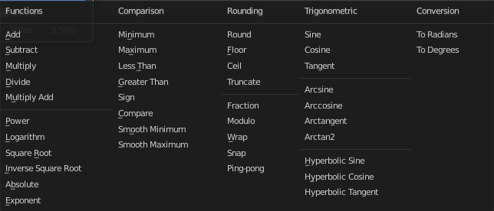
Operation
The mathematical operator to be applied to the input values:

Functions

Add
The sum of the two values.

Subtract
The difference between the two values.

Multiply
The product of the two values.

Divide
The division of the first value by the second value.

Multiply Add
The sum of the product of the two values with Addend.

Power
The Base raised to the power of Exponent.

Logarithm
The log of the value with a Base as its base.

Square Root
The square root of the value.

Inverse Square Root
One divided by the square root of the value.

Absolute
The input value is read with without regard to its sign. This turns negative values into positive values.

Exponent
Raises Euler’s number to the power of the value.

Comparison

Minimum
Outputs the smallest of the input values.

Maximum
Outputs the largest of two input values.

Less Than
Outputs 1.0 if the first value is smaller than the second value. Otherwise the output is 0.0.

Greater Than
Outputs 1.0 if the first value is larger than the second value. Otherwise the output is 0.0.

Sign
Extracts the sign of the input value. All positive numbers will output 1.0. All negative numbers will output -1.0. And 0.0 will output 0.0.

Compare
Outputs 1.0 if the difference between the two input values is less than or equal to Epsilon.

Smooth Minimum
Smooth Minimum.

Smooth Maximum
Smooth Maximum.

Rounding

Round
Round the input value to the nearest integer.

Floor
Rounds the input value down to the nearest integer.

Ceil
Rounds the input value up to the nearest integer.

Truncate
Outputs the integer part of the value.

Fraction
Fraction.

Modulo
Outputs the remainder once the first value is divided by the second value.

Wrap
Outputs a value between Min and Max based on the absolute difference between the input value and the nearest integer multiple of Max less than the value.

Snap
Round the input value to down to the nearest integer multiple of Increment.

Ping-pong
The output value is moved between 0.0 and the Scale based on the input value.

Trigonometric

Sine
The Sine of the input value.

Cosine
The Cosine of the input value.

Tangent
The Tangent of the input value.

Arcsine
The Arcsine of the input value.

Arccosine
The Arccosine of the input value.

Arctangent
The Arctangent of the input value.

Arctan2
Outputs the Inverse Tangent of the first value divided by the second value measured in radians.

Hyperbolic Sine
The Hyperbolic Sine of the input value.

Hyperbolic Cosine
The Hyperbolic Cosine of the input value.

Hyperbolic Tangent
The Hyperbolic Tangent of the input value.

Conversion

To Radians
Converts the input from degrees to radians.

To Degrees
Converts the input from radians to degrees.

Clamp
Limits the output to the range (0.0 to 1.0). See Clamp.

Outputs

Value
Numerical value output.


Use Clipping
Clipping options. Set up clipping for the stroke.

Delete Points
Deletes selected curve point.

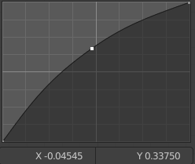
Curve window
Tweak and adjust the falloff curve by clicking at a curve point and dragging it around.
Double click adds a new point.
Holding down ctrl activates temporary snapping.
Holding down shift enables slower movement, which allows more accurate setting.

X / Y values
The x and y value of the currently selected point.

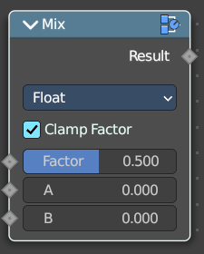
Mix
Allows to mix values and vectors in various ways. The node has three different modes. Float, Vector and Color. This node covers the Float mode

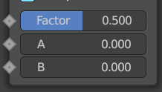
Input

Float

Factor
The mix factor.

A
Float value A input.

B
Float value B input.

Properties

Clamp Factor
Clamp the factor to 0-1 range.

Output

Result
The output value or vector.

